5 Euler and Quaternion

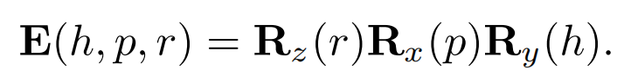

The order of the matrices can be chosen in 24 different ways [1636]; we present this one

because it is commonly used.

For example, interpolation between one set and another is not a simple matter

of interpolating each angle.

gimbal lock

In some situations, it is useful to have a procedure that extracts the Euler parameters,

h, p, and r, from an orthogonal matrix.

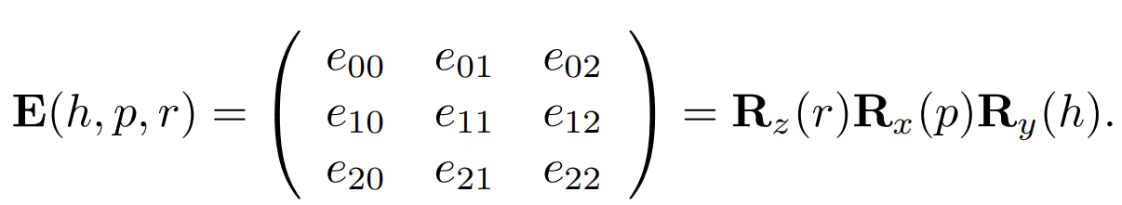

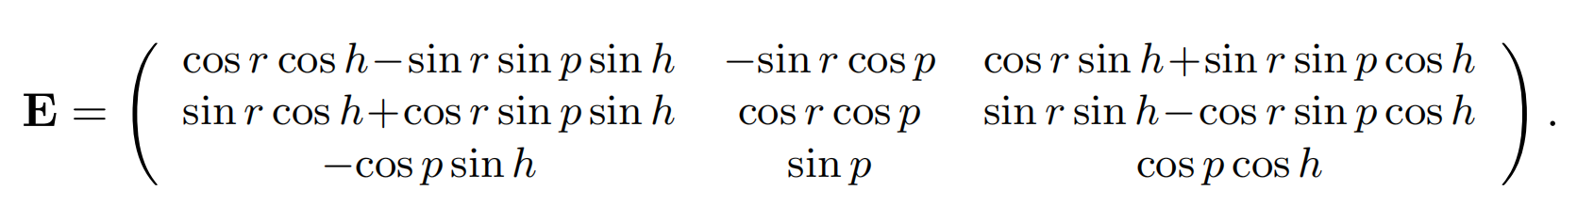

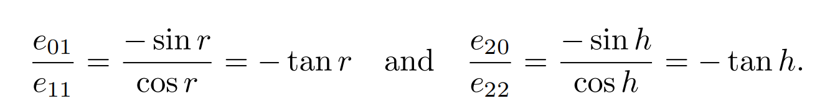

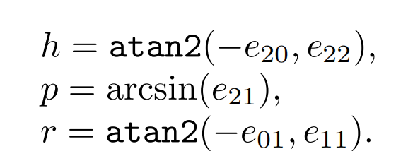

However, there is a special case we need to handle. If cos p = 0, we have gimbal lock and rotation angles r and h will rotate around the same axis so only one angle needs to be derived.

Rotation about an Arbitrary Axis

Assume that the rotation axis, r, is normalized and that a transform should be created that rotates α radians around r.

To do this, we first transform to a space where the axis around which we want to rotate is the x-axis. This is done with a rotation matrix, called M. Then the actual rotation is performed, and we transform back using M-1.

